Import Media Files
In CapCut, you can import video, audio, and photo files from your local storage to use in your video project.

Supported Files Types
You can import the following media types into your project library:
- Video (for example, MP4, AVI)
- Audio (for example, MP3, WAV)
- Photo (for example, JPG, PNG)

Procedure
- In the upper left navigation bar, select Media.
- In the media panel, select (+) Import icon.
Note: Make sure Local is selected.
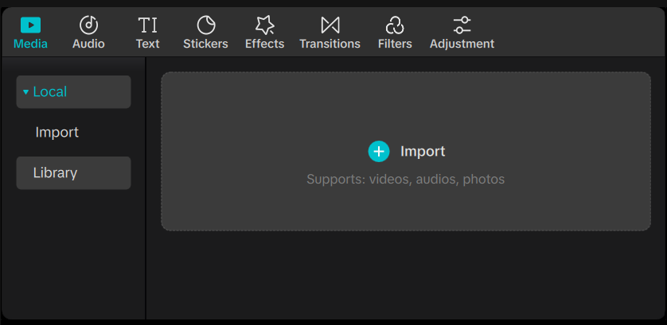
- In the Select a media resource dialog box, locate and select the files you want to import.
Tip: To select multiple files, select Ctrl as you select the files.
- Select Open.
The imported files appear in the media asset panel.

